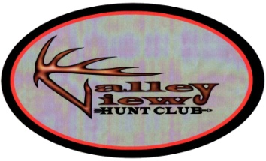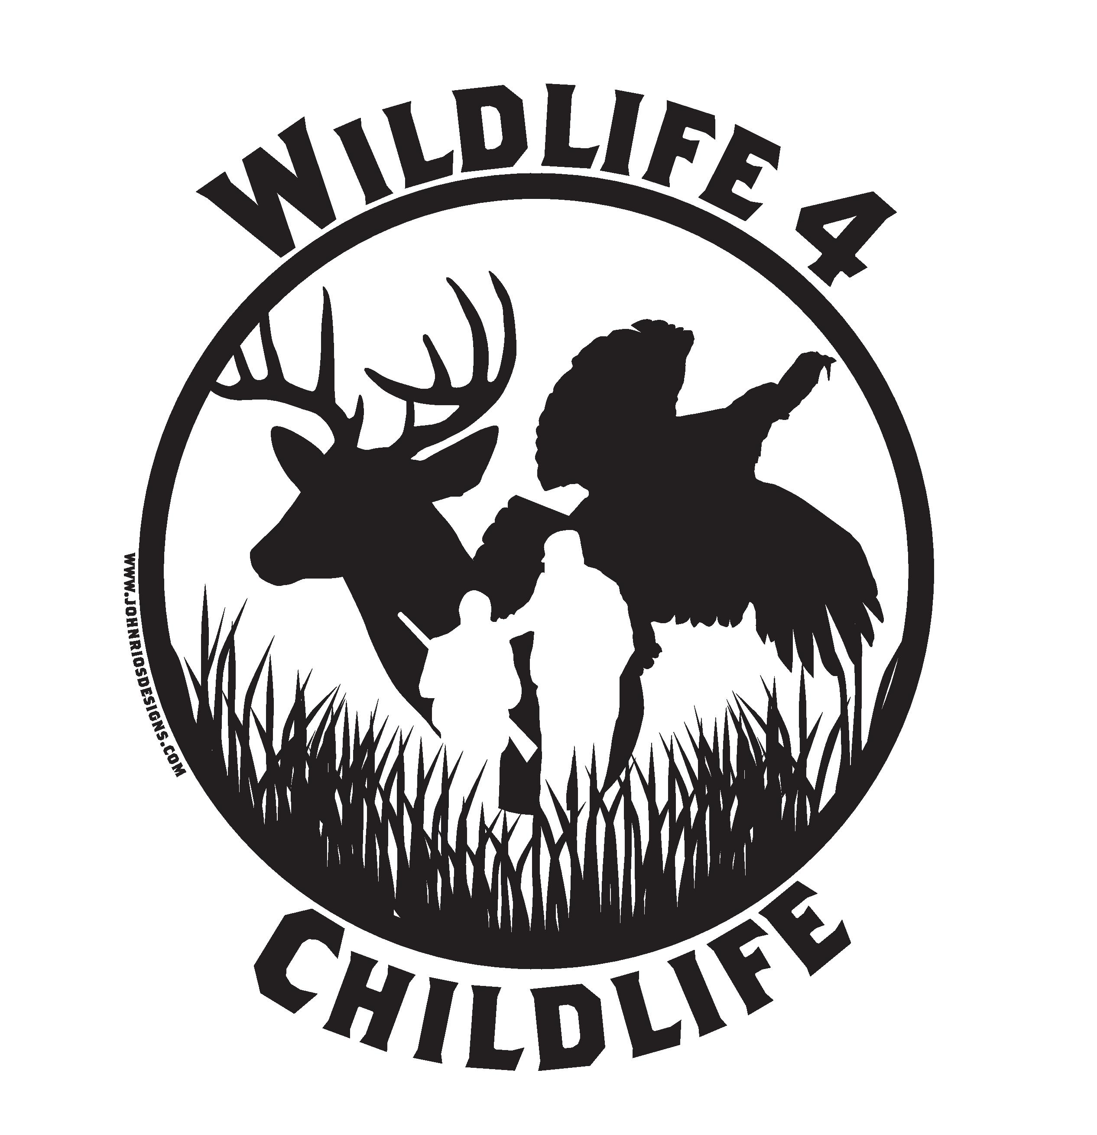
Brendan Prebish
Act-Upon

Al Pinter
Treasurer

Mark Moore
Executive Officer

Michael Kaminski
President
Ed Jarema
Vice-President

Brian Exton
Secretary

VVHuntClub.com


To Whom It May Concern,

On Saturday September 19, 2015, the Valley View Hunt Club will be hosting its 7th Annual, Night at the Races Charity Banquet in Parma, Ohio. The banquet is to raise money for Valley View Hunt club’s Wildlife 4 childlife program. This program grants fishing and hunting trips to local terminally ill children. The money pays in full for the child and their entire family to attend the adventure of the child’s choice.
Our club is selling advertisement space in the program that everyone will receive that night. The cost is $25 a quarter page ad (business card size) $50 half page ad, and $100 full page ad.
For any questions please feel free to contact:
- Brian Exton, Secretary at BrianExton@att.net /216-544-8469
- Ed Jarema, Vice-President at ejarema@sbcglobal.net /440-725-2936
We would like to thank you, on behalf of these children, in advance, for any help you are able to provide towards this great cause.

Sincerely,
Michael Kaminski Ed Jarema

President Vice-President
VVHC VVHC

